**DAILY ONLINE ACTIVITIES SUMMARY**

|  |  |  |  |  |  |  |  |
| --- | --- | --- | --- | --- | --- | --- | --- |
| **Date:** | **09/06/2020** | | | | **Name:** | **Sheetal** | |
| **Sem & Sec** | **8 B** | | | | **USN:** | **4AL16CS091** | |
| **Online Test Summary** | | | | | | | |
| **Subject** | | **BDA** | | | | | |
| **Max. Marks** | | **30** | | **Score** | | **26** | |
| **Certification Course Summary(Internship)** | | | | | | | |
| **Task** | **BI Automation-Creating BI custom Layout visual using Template**  **With python scripting** | | | | | | |
| **Company** | | | **Gain-Insights** | **Duration** | | | **8 hr** |
| **Coding Challenges** | | | | | | | |
| **Problem Statement:**  **1) Program to print binary number using recursion** | | | | | | | |
| **Status:completed** | | | | | | | |
| **Uploaded the report in Github** | | | | **Yes** | | | |
| **If yes Repository name** | | | | [alvas-education-foundation](https://github.com/alvas-education-foundation)/ **[sheetal-shettigar](https://github.com/alvas-education-foundation/sheetal-shettigar)** | | | |
| **Uploaded the report in slack** | | | | **Yes** | | | |

ONLINE TEST

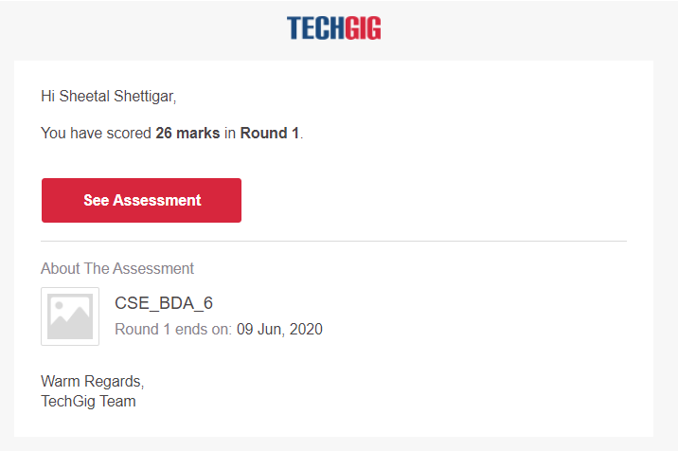

CODING CHALLENGE:

PROGRAM 1 :

def convertToBinary(n):

if n > 1:

convertToBinary(n//2)

print(n % 2,end = '')

dec = 34

convertToBinary(dec)

print()